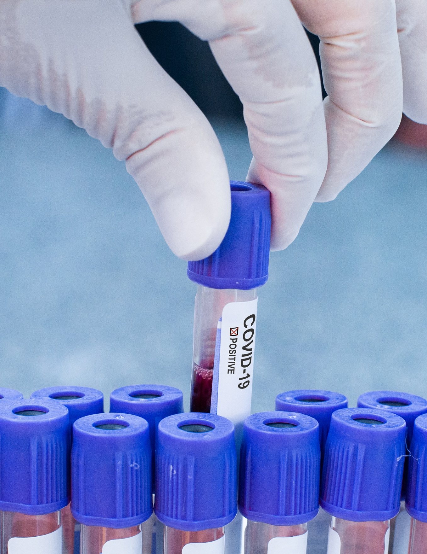


HEALTHCARE DASHBOARD
Data Analysis and Visualization [3CS103ME24]
Prepared By: | Deep Joshi  24BCE152 | Ziyankhan Pathan  24BCE146

Executive summary
Modern hospital systems face a dual mandate: providing clinical care while managing throughput bottlenecks and financial attrition. This report details the design, implementation, and analytical findings of a 4-dashboard command suite designed to unify operational flow, clinical quality, revenue cycles, and payer claim adjudication into an actionable executive tool.
Through an upfront feature engineering pipeline in Python, 13,214 patient encounters were transformed to support direct drag-and-drop visualizations in Tableau without sacrificing performance or adding workbook calculation overhead. The platform identifies critical operational bottlenecks, maps comorbidity-acuity risks, details cost structures across an $18M+ billed revenue portfolio, and pinpoints $39.16M in denied claim risk driven primarily by front-desk administrative errors.

Table of Contents
- Dashboard 1: Executive Hospital Operations & Patient Flow Command Center
- Dashboard 2: Clinical Acuity, Quality of Care & Patient Safety Monitor
- Dashboard 3: Hospital Revenue Cycle & Departmental Financial Suite
- Dashboard 4: Payer Performance, Claim Adjudication & Denial Root Causes

Dashboard 1: Executive Hospital Operations & Patient Flow Command Center
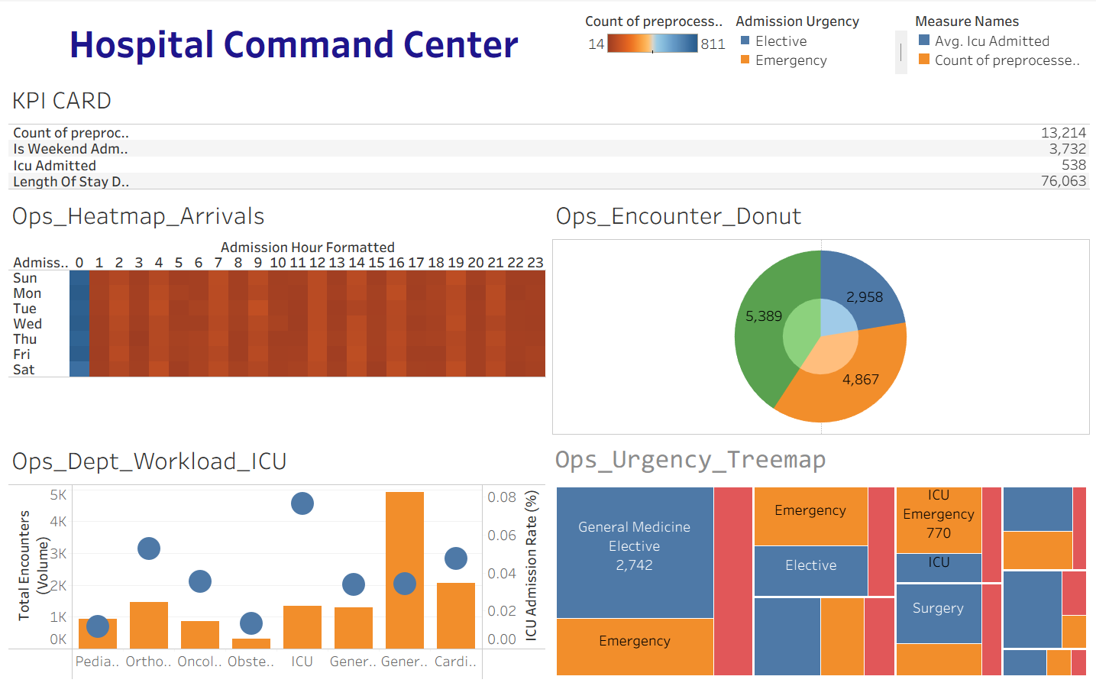

Objective
Monitor bed utilization, peak arrival times, and departmental throughput for resource planning.

Key Visualizations
- Overall KPI (Key Performance Indicator) Table
- Patient Arrival Heatmap
- Patient Encounter Donut Chart
- Department Workload Scatter + Bar Plot
- Patient Urgency Treemap

Dashboard 2: Clinical Acuity, Quality of Care & Patient Safety Monitor

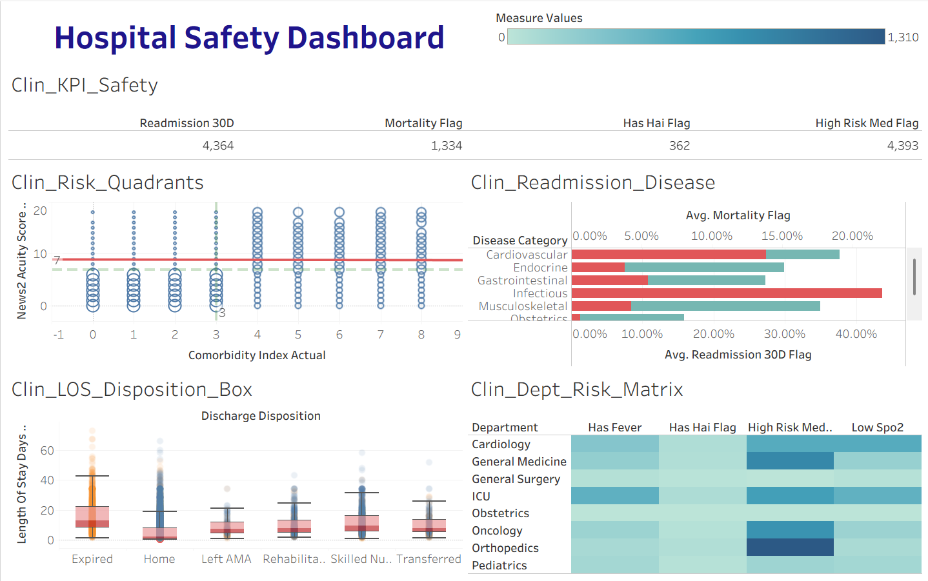

Objective

Track patient safety indicators, 30-day readmissions, mortality, and length-of-stay outliers.

Key Visualizations
- Patient Disposition KPI (Key Performance Indicator) Table
- Clinical Risk ( News Acuity vs Comorbidity Index) Circle Plot+ Regression
- Clinical Readmission Dual Axis Bar Plot
- Length of Stay vs Disposition Status Scatter + Boxplot
- Department Wise Risk Matrix Heatmap

Dashboard 3: Hospital Revenue Cycle & Departmental Financial Suite

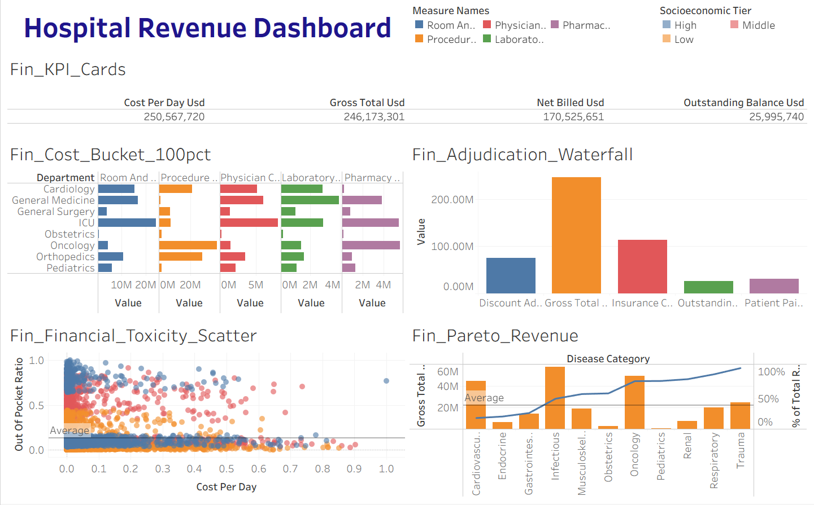

Objective

Analyze financial attrition from gross billing down to net cash collection while monitoring patient out-of-pocket toxicity.

Key Visualizations
- Revenue KPI (Key Performance Indicator) Table
- Multi Class Department Revenue Bar Chart
- Adjudication Waterfall Bar Chart
- Financial Toxicity Scatter + Average Plot
- Revenue Pareto Plot with Bar Chart and Average Reference Line

Dashboard 4: Payer Performance, Claim Adjudication & Denial Root Causes

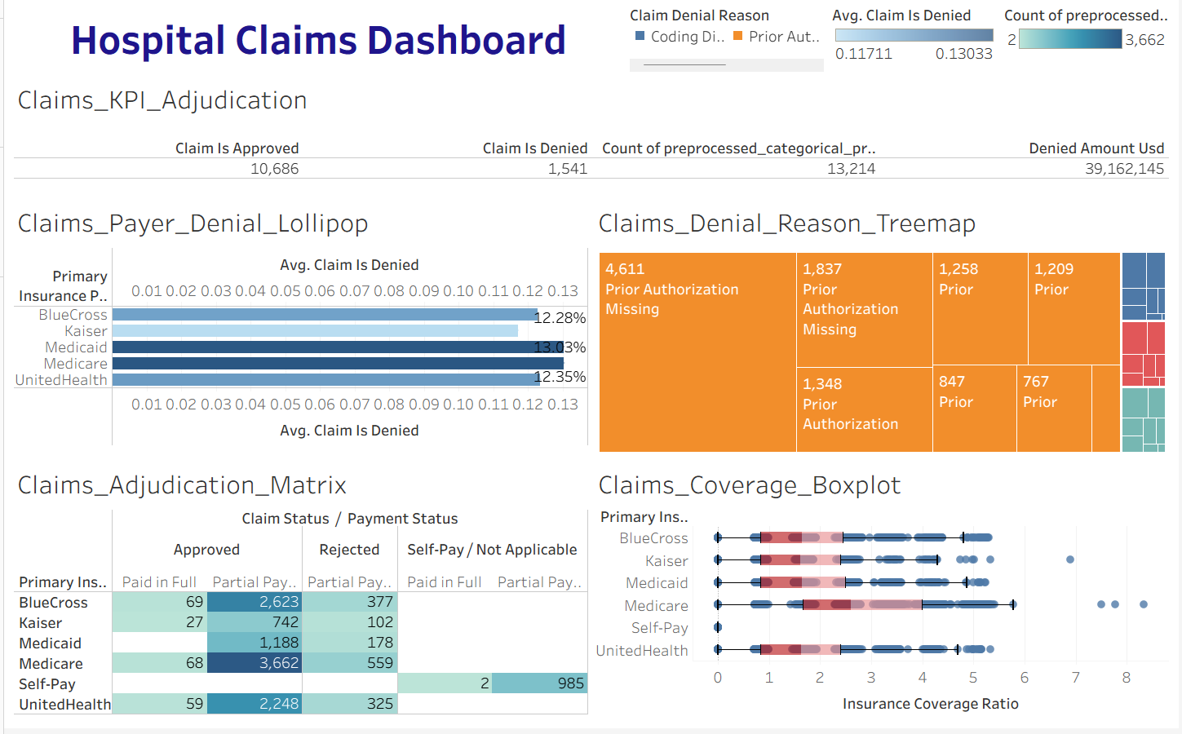

Objective

Audit payer performance, pinpoint claim rejection rates, and isolate administrative root causes for denial recovery

Key Visualizations
- Claims KPI (Key Performance Indicator) Table
- Average Claim Denied by Insurance Provider Bar Chart
- Claim Denial Reason Treemap
- Claims Adjudication Matrix
- Claims Coverage Ratio vs Primary Insurance Provider Scatter Plot + Box Plot

Key Operational Findings & Executive Recommendations
- Front-Desk Pre-Authorization Reform: Over $39.16M in billed revenue is blocked by claim denials, with Prior Authorization Missing identified as the primary administrative cause. Implementing mandatory automated pre-authorization verification during patient intake will help recover revenue without increasing clinical delivery costs.
- Shift Allocation Alignment: The arrival heatmap reveals consistent peak rush hours during early morning windows (00:00–02:00). Realigning nurse and triage physician shifts to match these operational arrival windows will reduce emergency department congestion and streamline ICU transfers.
- Targeted Readmission Risk Protocol: Patients presenting with Cardiovascular and Infectious conditions exhibit 30-day readmission rates approaching 40%. Introducing post-discharge remote monitoring and 48-hour follow-up calls for these specific disease cohorts will help lower readmission penalties.
- Post-Acute Discharge Planning: Boxplot distribution analysis indicates that patients transitioning to Skilled Nursing Facilities drive significant stay duration outliers (40+ days). Early social worker engagement during admission will help streamline post-acute placement and free up inpatient bed capacity.


Conclusion
This project demonstrates the design and execution of an enterprise-grade healthcare analytics platform built over 13,214 patient encounters. By leveraging an upfront data-engineering pipeline in Python, the dashboard suite achieves a Zero-Calculated-Field architecture in Tableau, eliminating workbook performance bottlenecks while delivering real-time interactive decision support.
Through four integrated command centers, the platform successfully bridges the gap between clinical operations, patient safety, financial management, and revenue cycle integrity:
- Operational Optimization: Arrival heatmaps and workload metrics provide clear data to optimize shift scheduling and manage ICU escalation pressure.
- Clinical Safety Improvement: Stratifying patients by physiological acuity (NEWS2) and comorbidity indices (CCI) isolates high-risk cohorts, offering actionable insights to reduce 30-day readmissions and mortality rates.
- Financial & Revenue Cycle Integrity: Dissecting departmental cost structures and analyzing claim adjudication uncovers $39.16M in denied claim risk. Isolating "Prior Authorization Missing" as the primary denial driver proves that revenue leakage can be mitigated through administrative intake reform without affecting patient care quality.
Ultimately, this project highlights how modern data visualization and upfront feature engineering empower hospital administrators, clinicians, and finance leaders to make data-driven decisions that enhance patient outcomes while safeguarding financial sustainability.

